**SMART FASHION RECOMMENDER APPLICATION**

ARCHANA S **MENTOR**

KARUNYA SWEETLIN A MR.S.SANKAR.,M.E.,

JANANI J

JESSICA G

**PROBLEM DESCRIPTION:**

We have come up with a new innovative solution through which you can directly do your online shopping based on your choice without any search. It can be done by using the chatbot.

The user will login into the website and go through the products available on the website.  Instead of navigating to several screens for booking products online, the user can directly talk to Chatbot regarding the products.  Get the recommendations based on information provided by the user.

The role of the admin is to check out the database about the stock and have a track of all the things that the users are purchasing.

Using chatbot we can manage user's choices and orders. The chatbot can give recommendations to the users based on their interests. It can promote the best deals and offers on that day.

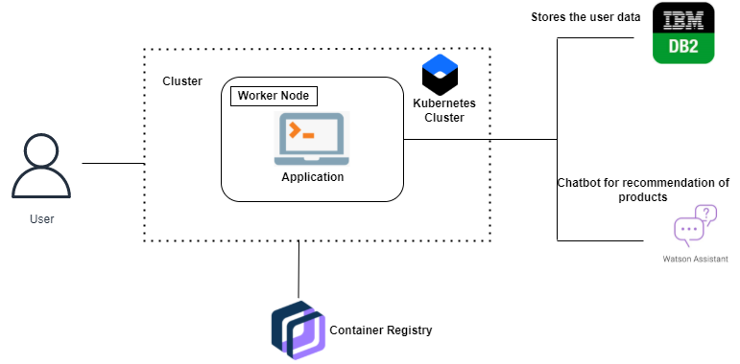**TECHNICAL STACK**

* HTML
* JAVASCRIPT
* DOCKER
* IBM CLOUD
* IBMCLOUDNOBJECT STORAGE
* IBM DB2
* IBM CONTAINER REGISTRY
* PYTHON-FLASK
* KUBERNETE